LEARN CLOUD COMPUTING LIKE A GAME

**Nabeel Ahmed**

**Kashir Hasnain**



Department of Computer Science

COMSATS UNIVERSITY ISLAMABAD

ATTOCK CAMPUS-PAKISTAN

SESSION 2018-2022

LEARN CLOUD COMPUTING LIKE A GAME

*Undertaken By:*

**NABEEL AHMED**

CIIT/FA18-BSE-030/ATK

**KASHIR HASNAIN**

CIIT/FA18-BSE-064/ATK

*Supervised By:*

**DR SADAF YASMEEN**

A DISSERTATION SUBMITTED AS A PARTIAL FULFILLMENT OF THE REQUIREMENTS FOR THE DEGREE OF BACHELOR OF SCIENCE IN SOFTWARE ENGINEERING

Department of Computer Science

COMSATS UNIVERSITY ISLAMABAD

ATTOCK CAMPUS-PAKISTAN

SESSION 2018-2022

**UNDERTAKEN**

We certify that this is my/our work. The work has not, in whole or in part, been presented else for assessment been used from other sources it has been properly acknowledged. If this statement is untrue, we acknowledge that we will have committed an assessment offense and shall be liable to punishable action under the plagiarism rules of HEC.

______________ ____________________

NABEEL AHMED KASHIR HASNAIN

FA18-BSE-030 FA18-BSE-064

Dated: _________ Dated: _________

**FINAL APPROVAL**

Certified that we have read this project report submitted by Mr. (Nabeel Ahmed and Kashir Hasnain) and it is, in our judgment, of sufficient standard to warrant its acceptance by the Department of Computer Science, COMSATS University Islamabad, Attock Campus, for the BSSE degree.

***Committee:***

1. External Examiner ____________

Dr. Shakeel Arshad

Assistant Professor

University of Malakand

2. Supervisor _____________________________

Dr. Sadaf Yasmin

Assistant Professor

COMSATS University Islamabad,

Attock Campus

3. Head of the Department ___________________________

Dr. Khalid Mehmood Awan

Associate Professor HOD (CS)

COMSATS University Islamabad,

Attock Campus

**DEDICATION**

In the name of Allah, Most Gracious, Most Merciful. First, we would like to thank our parents and teachers who helped us financially and morally at all times. We would also like to thank DR. Sadaf Yasmeen for guiding us to work hard. We found it very helpful to discuss our plan. His critical comments on our work have made us think of new ideas. We are thankful to Allah Almighty, who gave us all the resources to make this project for the benefit of mankind.

**ACKNOWLEDGMENTS**

I would like to acknowledge everyone who played a role in my academic accomplishments. First, we would like to thank our parents and teachers who always helped us financially and morally. We would also like to thank DR. Sadaf Yasmeen for guiding us to work hard. Without you, I could never have reached this current level of success. We found it very helpful to discuss our plan. His critical comments on our work have made us think of new ideas. We are thankful to Allah Almighty, who gave us all the resources to make this project for the benefit of mankind. Thank you all for your unwavering support.

**PROJECT BRIEF**

PROJECT NAME LEARN CLOUD COMPUTING LIKE A

GAME

ORGANIZATION NAME COMSATS UNIVERSITY ATTOCK

UNDERTAKEN BY NABEEL AHMED

KASHIR HASNAIN

SUPERVISED BY DR SADAF YASMEEN

DEPARTMENT OF COMPUTER SCIENCE COMSATS UNIVERSITY ATTOCK

STARTED ON 15-02-21

COMPLETED ON 06-08-22

COMPUTER USED CORE i5 FIFTH GENERATION

SOURCE LANGUAGE UNITY USING C#

OPERATING SYSTEM WINDOWS 10

TOOLS USED Unity 3D,

Visio 2016,

Star UML,

Blender

**ABSTRACT**

This software is for learning cloud computing. We have studied those students faced so many troubles while clearing their cloud computing skills and the learning cost too much as compared to other technologies. So, in this project, we have made a game that will help students to learn the concepts about cloud computing with to help of Virtual Reality, so that the student can learn and concentrate on the skills. Students will get a better and better learning process while using this app.

**Table of Contents**

CHAPTER 1 INTRODUCTION 1

1.1 Introduction 2

1.2 Control 2

1.2.1 Achievements 2

1.2.2 3D Models 3

1.3 Application Strategy 3

1.4 Actions 3

1.5 Objectives 3

1.6 Scope 3

1.7 Problem Statements 3

1.8 Proposed Solution 4

CHAPTER 2 Literature Review 5

2.1 Literature Review 6

2.2 Competitors 6

2.2.1 First Student Shoot 6

CHAPTER 3 REQUIREMENTS SPECIFICATION 7

3.1 Requirement Specifications 8

3.1.1 Functional Requirements 8

3.1.2 Non-Functional Requirements 9

CHAPTER 4 PROJECT DESIGN 12

4.1 Methodology 13

4.2 Use Case Diagram: 13

4.2.1 Use Case Diagram: 14

4.3 Activity Diagram: 14

4.3.1 Activity Diagram: 15

4.4 Sequence diagram: 16

4.4.1 Sequence diagram: 16

4.4.2 Sequence diagram: 17

4.5 Context Diagram: 17

4.6 DFDs: 18

CHAPTER 5 Implementations 20

5.1 App Development Stages: 21

5.1.1 App Story 21

5.1.3 Designing Game Environment: 21

5.1.4 Converting 3D App into Virtual Reality: 21

5.1.5 Choosing Game Development Engine: 21

5.1.6 Choosing VR Platform: 22

5.2 IDEs 22

5.2.1 Visual Studio: 22

5.3 Designing Tools 23

5.3.1 Unity Hub: 23

5.4 User Interface 23

5.4.1 Login Panel 23

5.4.2 Create Account 24

5.4.3 Operating System 24

5.4.4 Docker 25

5.4.5 Kubernetes 25

CHAPTER 6 Evaluation 26

6.1 Evaluation: 27

6.1.1 Unit Testing 27

6.2.2 Integration Testing 28

6.3.3 Function Testing: 31

CHAPTER 7 Conclusion and Future Work 33

7.1 Conclusions …………………………………………………………………….34

**CHAPTER 8 REFRENCES**……………………………………………………….35

References**………………………………………………………...…………..…..36**

**List of Figures**

Figure 4. 1 Use Case Diagram of the whole system 14

Figure 4. 2 Activity Diagram of Main Menu 15

Figure 4. 3 Sequence Diagram of Account Creation 16

Figure 4. 4 Sequence Diagram of Learning and Quiz 17

Figure 4. 5 Context Diagram 17

Figure 4. 6 DFD 18

Figure 5. 1 Login 24

Figure 5. 2 Create Account 24

Figure 5. 3 Operating System 18

Figure 5. 4 Docker 25

Figure 5. 5 Kubernetes 18

**List of Tables**

Table 3. 1 Display 8

Table 3. 2 Deployment Tools 8

Table 3. 3 Controls 8

Table 3. 4 Operating System Control 9

Table 3. 5 Student Interface 10

Table 3. 6 Quality Graphics 10

Table 3. 7 Performance 10

Table 6. 1 Unit Testing…………………..…………………………….…………….28

Table 6.2 Player Learning……….………………………………….…………….30

Table 6.3 Quiz…………..………………………………………………….……….31

Table 6.4 score Updating………………………..…….…………………….……….32

Table 6.5 score Testing……………………………………………………….…….33

# **CHAPTER 1**

# **INTRODUCTION**

## **Introduction**

This project is named “Learn Cloud Computing like a Game “in which we will teach about cloud computing concepts via the Virtual Reality Game. This Application consists of 2 Parts (Learn and Quiz). This app is for beginner students who didn’t know about cloud computing but who what to learn cloud computing. We cover the private cloud which was deployed internally on your Local Machine. We make a game in which we will cover some concepts of Cloud Computing. This Project consists of 4 chapters for learning cloud computing. In this project, we have 4 chapters (Operating system: Virtualization, Docker: Container which separates the application from your host OS, Kubernetes: managing containers and Deployment: Up the Website). This project also consists of a quiz that has scored points for every chapter and if the student has chosen an incorrect answer, then the score is deducted from the obtained score. The Game is designed in such a way that maximum parts interact with the students. For example, in the first chapter Operating System (D & Ahmed, n.d.), the virtualization concept is firstly explained then the student will make a Guest OS on Virtual Machine. If he exceeds the limit, it will show an error. (Shen, 2014)

## **Control**

The player experiences to learn cloud computing in a VR environment that will be presented in the form of the Model Simulation. The student can learn about cloud computing in a different chapter like Operating system, Kubernetes, Docker, and Deployment of web in a VR (VR Connection, n.d.). If a student will clear the first chapter quiz, then he will go to the next chapter. The app is organized in different sections that correspond to the different parts to cover with the help of 3D Models in a VR. The student progresses in the app by each requirement of cloud computing. Each section has its objectives.

**1.2.1 Achievements**

The student advances in the application by finishing each chapter and getting the next objective of cloud computing. Each section has its tasks. A set of objectives is given in every chapter. After completion of the objectives of the corresponding chapter students will move to the next chapter having different objectives.

### **1.2.2 3D Models**

The application will focus on the Simulation of 3D models, our models are designed in the blender and its simulation is done in Unity.

## **1.3 Application Strategy**

This application is designed to teach the students about Cloud Computing Concepts, as we know that Cloud Computing is a very huge field, and difficult to clear the concepts.

## **Actions**

This game consists of 4 chapters that have lessons to learn cloud computing. The student login into the account and the first chapter game starts. After learning the lecture, which consists of a 3D simulation he can assess the quiz of that specific chapter. If the student passed the quiz of the first chapter, which is the operating system, then he will be able to get access to the next chapter. This game also consists of score points for every chapter quiz. This app is for beginner students who didn’t know about cloud computing but who what to learn cloud computing.

## **1.5 Objectives**

* To teach all the concepts of Cloud Computing to beginner students.
* Students will learn Cloud Computing in a Very Short period.
* To remove the difficulties of a beginner who are very confused about that what they will study or what they did not study in a very short time.

## **1.6 Scope**

Our project scope includes the following:

* The main purpose is less time-consumption for students to learn and this issue is resolved by this system as it performs Analytic process quickly.
* The motivation of this project is to learn the architecture of cloud computing.
* Learning cloud computing like a game is that, when a new student wants to learn cloud computing and they read books, articles to learn, but the image of how cloud computing works was not made for maximum students.
* This application willfully made the image/architecture in his mind.

## **1.7 Problem Statements**

* There is no proper application that provides learning via 3D models.
* As we know that the students were now shifted from manual phones to a smartphone with the help of a smartphone, we will make an app that also includes a Quiz for a better understanding.
* Mostly the students face troubles while learning Cloud Computing because it is a very vast field, and it is hard to cover it in a short period.
* Time-consuming need a lot of time to go and attend the classes in academies or watch the videos.

## **1.8** **Proposed Solution**

In this system, we are providing a platform that allows learners to understand complete information using virtual reality along with voice and descriptions with the help of a VR and a Quiz for a better understanding.

# **CHAPTER 2**

# **Literature Review**

## 

## **2.1 Literature Review**

Virtual reality is the reality trending in today's world since 2014 and is still not at the mature stage. Virtual Reality provides the interaction of players to the game world in an almost real way by doing physical activity you interact with virtual gameplay. Studying things in Virtual reality is one of the latest achievements of technology. By determining all the needs and researching needs, we came through Unity 3D a free easiest way to develop gaming applications. Moreover, the other thing is that the world is moving from manual phones to a smartphone, and it is easy for us that we will make an app that can be easily connected, and we will connect with a Quiz for a better understanding.

## **2.2 Competitors**

The rapid penetration of advanced technology into every aspect of society, how, when, and we operate, how individuals and companies manage themselves, and the game to complement other deployment companies. How our game should be structured is undergoing significant change. Continuing and developing similar games will not do us any good in completing them. This project is about a learning game with includes with Scenario Based Quiz. Our motto is to provide better knowledge that every student can understand easily. (Learn Cloud Computing, n.d.)

### **2.2.1 First Student Shoot**

The FPS is a popular VR-based game in which the environment is provided in such a way that the player will need to divert his full attention towards understanding and in learning. The student will be able to experience the most extreme environments by interacting with the game.

# **CHAPTER 3**

# **REQUIREMENTS SPECIFICATION**

## **3.1 Requirement Specifications**

In this chapter, we have all the functional and Non-Functional requirements of our application.

### **3.1.1 Functional Requirements**

. In our project these are four Functional requirements:

1. The User login to the Account and learn the different modules of the Cloud Computing.
2. Every Module of Game has Quiz at the end and after Completion of the Quiz, the user sees the score.
3. When Student Passed the Quiz then he will move towards next modules.

Table 3. 1 Display

|  |  |
| --- | --- |
| **FR-NO** | FR-01-01 |
| **FR-Name** | Learning |
| **Summary** | The Student Learn the different modules through the simulation and the voice over. |

Table 3. 2 Deployment Tools

|  |  |
| --- | --- |
| **FR-NO** | FR-01-02 |
| **FR-Name** | Quiz |
| **Summary** | The student give quiz through different questions |

Table 3. 3 Controls

|  |  |
| --- | --- |
| **FR-NO** | FR-01-03 |
| **FR-Name** | Control |
| **Summary** | It must be controlled with VR Recast. |

Table 3. 4 Operating System Control

|  |  |
| --- | --- |
| **FR-NO** | FR-01-04 |
| **FR-Name** | Quiz Progress save in VR |
| **Summary** | The user progress saved in the database. |

### **3.1.2 Non-Functional Requirements**

Our Project consists of these Non-Functional Requirements.

Performance: -

1. Easy to access the system.
2. After that, we will go to the home page.
3. On the home screen, we have different options, and we will go to the lecture and we see 3D VR lectures.
4. After seeing the lecture, we will be able to give the quiz chapter-wise.
5. T are 4 chapters if we will pass the quiz then we will be supposed to give the quiz on the next chapter.
6. This rule will be applied to all the next chapters.
7. If any student has passed the first chapter, then the proper grades will be assigned to him.

Availability: -

1. This course is eligible for all students to study. T is no age limit for studying this course.
2. This course is workable only for Android devices which version is above Android 5.
3. This course is available free of cost.
4. T are 4 chapters if we will pass the quiz then we will be supposed to give the quiz on the next chapter.
5. This rule will be applied to all the next chapters.

Security: -

1. Every student will log in first, then he/she will be allowed to enter into the app.
2. Every student's record of marks and chapter record which he gives the quiz record will be saved according to his profile.
3. If a student will not pass the quiz, then he will not be able to move to the next chapters.

Table 3. 5 Student Interface

|  |  |
| --- | --- |
| **NFR-NO** | NFR-01-01 |
| **NFR-Name** | Student Interface |
| **Summary** | The student interface should be clean and compatible with mobile screens and UI must be controlled through Gear VR. |

Table 3. 6 Quality Graphics

|  |  |
| --- | --- |
| **NFR-NO** | NFR-01-02 |
| **NFR-Name** | Quality Graphics |
| **Summary** | This app must have high-end 3D Graphics. |

Table 3. 7 Performance

|  |  |
| --- | --- |
| **NFR-NO** | NFR-01-03 |
| **NFR-Name** | Performance |
| **Summary** | The primary performance requirements are the speed of the play and quizzes. It must be with good FPS on a system to have more reality |

# **CHAPTER 4**

# **PROJECT DESIGN**

## **4.1 Methodology**

In this system, we'll use the incremental method which allows us to modify or add up modules or functionalities as per demand/requirement.

Incremental phases:

* 1. Requirement gathering
  2. Design.

## **4.2 Use Case Diagram:**

The use case diagram is used to briefly discuss the need for the system. This includes actions taken by the actors, systems, students, and specific actors. This method is used for system analysis and helps identify, define and organize system requirements. There is only one actor in our application and that is a student.

**Components of use case:**

* A use case defines the relationship among and between the actors.
* The threshold is used to identify system actors, system students.

**Use Case Description:**

This use case is based on Learn Cloud Computing like a Game. In this use case, the student will get two options at the start of the app which is sign up and log in. First, we will go for Signup the account and then we will log in if the account is already signed up first then the student will automatically go to login. After that student will show in the above diagram. As we discussed earlier the first student will go to learn the. After that, the student will go for quizzes and first, he will give the operating system and after passing the quiz, then he will be supposed to learn and give the quiz of the next chapter, which is Kubernetes after passing Kubernetes then he will be able to learn and give the quiz of Docker after that he will be supposed to learn and give the quiz of deployment of the web pages. (Hung, 2021)

### **4.2.1 Use Case Diagram:**

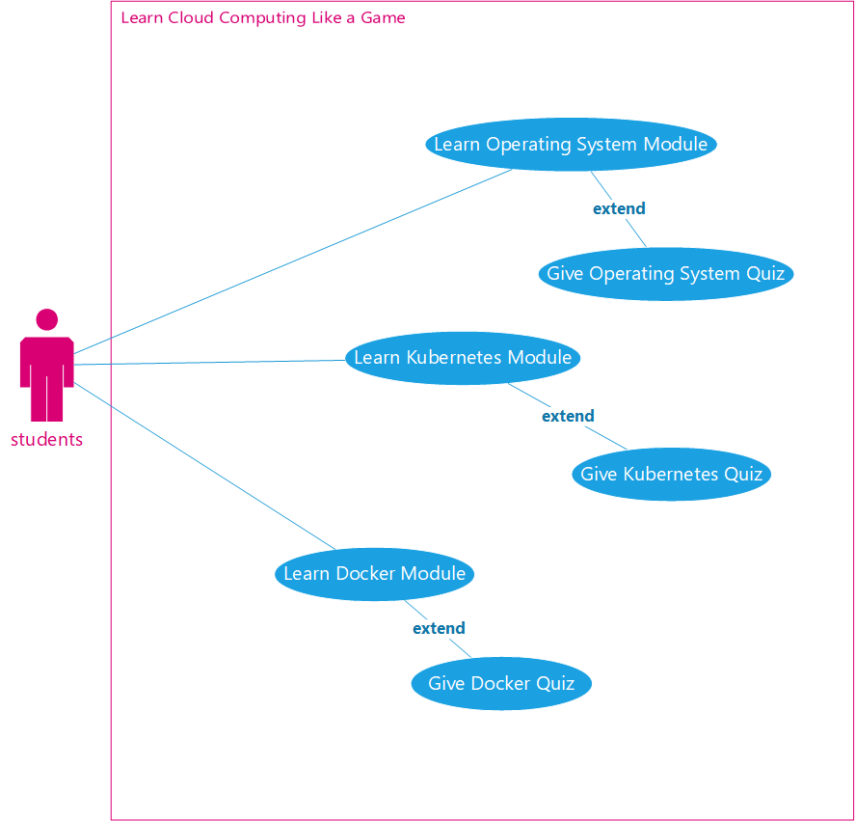

Figure 4. 1 Use Case Diagram of the whole system

## **4.3 Activity Diagram:**

In this array, we are showing a graphical representation of the workflow of phased activities. This diagram shows the overall flow control. Activity diagrams can be formed with a small number. Are the key shapes

* Arrows show the order of activities in which they are happening.
* Start represented with a black circle.
* The action is represented by a rounded rectangle.
* The end is represented by an encircled black circle.

### **4.3.1 Activity Diagram:**

When the home page will be opened the student will get further four options to go to the unity with the help of a button. In the unity, we will see 4-chapter options like operating system Kubernetes Docker deployment of web pages. And first, he will give the operating system and after passing the quiz, then he will be supposed to learn and give the quiz on the next chapter, which is Kubernetes after passing Kubernetes then he will be able to learn and give the quiz of Docker after that he will be supposed to learn and give the quiz of deployment of the web pages.

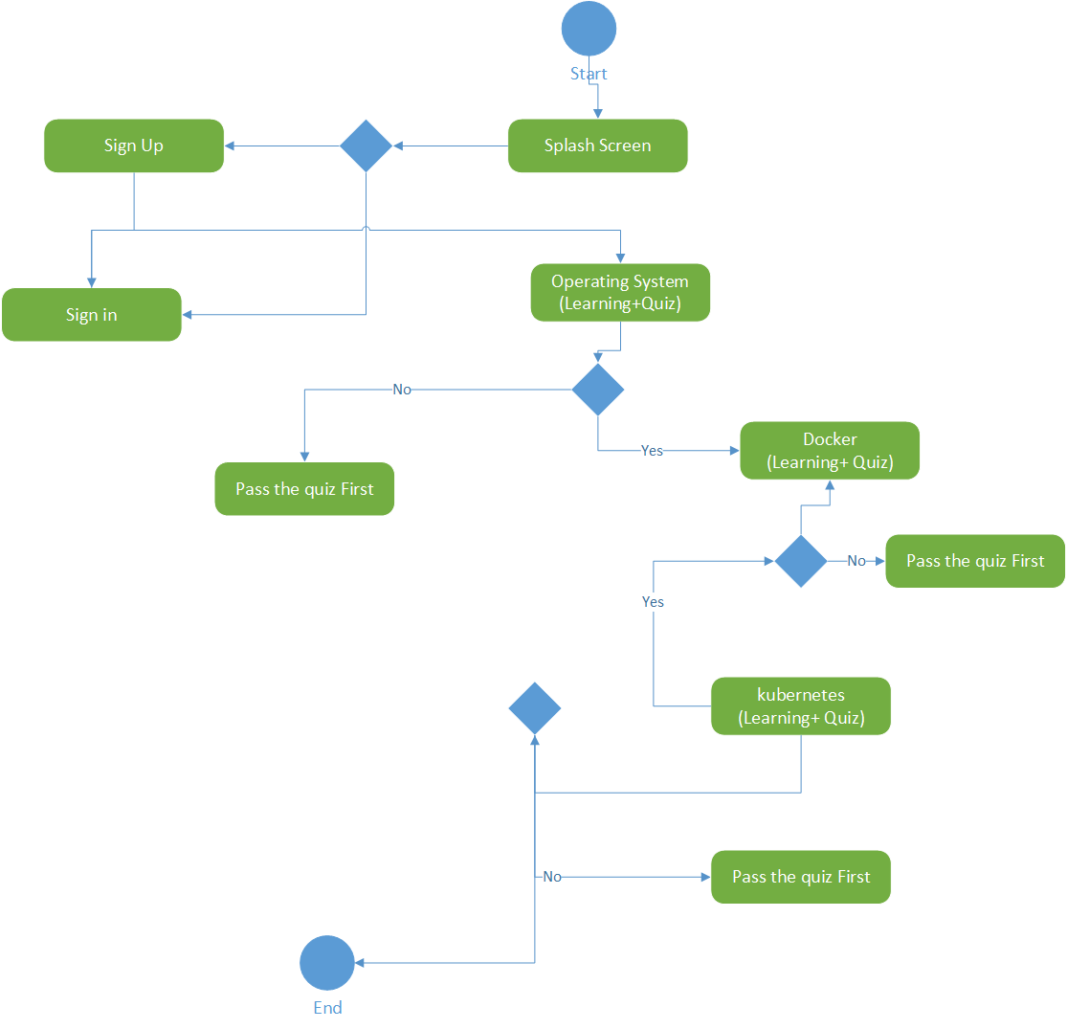

Figure 4. 2 Activity Diagram of Main Menu

## **4.4 Sequence diagram:**

A sequence diagram is defined in the software system configuration. It is represented by parallel lines that represent events and horizontal lines at the beginning and end that represent the system and the student.

### **4.4.1 Sequence diagram:**

Figure 4. 3 Sequence Diagram of Account Creation

The first student will get two options at the start of the app which are Signup and log in. First, we will go for Signup and then we will log in if the account is already signed up first, then the student will automatically go to login if not, then he has to sign up first then after login then he will be able to enter into the app. After that student will go to the home page.

**4.4.2 Sequence diagram:**

Figure 4. 3 Sequence Diagram of Learning and Quiz

This sequence diagram is about a learn and Quizzes. First, we will open learning and Quiz is operating system after passing Quiz of an operating system after that we will learn and then we will give the Quiz of the Kubernetes after passing that we will learn and give the Quizzes in 3D Docker after passing that we will learn and give the Quizzes of deployment of web pages.

## **4.5 Context Diagram:**

Student

Unity constraints

Play and give Load menu

Select option Option load

Learn and quiz Marks

Barrier

Figure 4. 4 Context Diagram

In this context, the diagram student starts the playing by clicking the icon on the chapters in the unity. Then after that unity constraints, load the menu for the student by clicking a button. After that, students will select a stage. The VR 4 chapter will display, and the student will learn and give Quizzes of four chapters.

## **4.6 DFDs:**

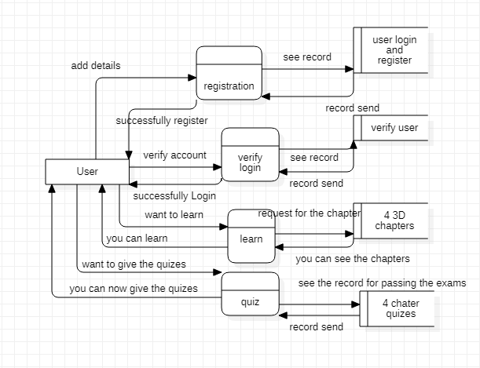

Figure 4. 5 DFD

This DFD tells us that first, we will register our account, they will be able to log in after login the app start from the home page after that student will open the unity while clicking the learn button. After that, the student will get further four options like operating system Kubernetes Docker deployment of web pages. We can open it one by one but before that, we will open a chapter by chapter first we will open the operating system, then Kubernetes after that we will open Docker and after that, at last, we will open deployment of web pages we can lesson it but not randomly we have to pass first chapters according to the order.

**CHAPTER 5**

**Implementations**

**5.1 App Development Stages:**

Following are the incremental phases to developing the full app.

**5.1.1 App Story**

Here is how we designed our application, Story. Our application is all about virtual reality. This is a learning app for people who want to learn the procedures of Cloud Computing from the very basics (Youtube, 2019). The functional phases of this app are learning and giving quizzes. The first phase will be the learning phase of 3 Chapters and the second will be quizzing from those three chapters. As we discussed earlier the first user will go to learn the lectures which are operating system, Kubernetes, and Docker. (Docker Images, n.d.) After that, the user will go for quizzes and first, he will give the operating system and after passing the quiz then he will be supposed to give the quiz of the next chapter which is Kubernetes after passing Kubernetes then he will be able to give the quiz of Docker (Kubernetes, 2018).

**5.1.2 Designing Software Selection**

Following are the tools which are used to design the different components of the app.

* Blender 3D.
* Unity 3D Engine.
* Visual studio.

**5.1.3 Designing Game Environment:**

We designed all our models in Blender 3D and other designing software. After the completion of modelling, we applied to texture them for a better look.

**5.1.4 Converting 3D App into Virtual Reality:**

After the completion of the 3D app, it will be converted into virtual reality (VR) based by configuring the SDK with unity.

**5.1.5 Choosing Game Development Engine:**

We had 3 options for game development engine

1. Unreal Engine

2. Unity3D

3. Game Maker Studio

We choose Unity 3D due to its easy interface and most popular and easy to develop Mobile games. Unreal Engine and Game Maker studio are used to develop desktop games mostly. Unity is a cross-platform development engine, everything is built-in as compared to other engines like unreal engine etc.

**Features:**

**General:**

* It supports programming languages JavaScript and C# etc.
* It has good graphics.
* 64-bit editor.
* Action-Packed Physics

**Graphics:**

* 3D Graphics.
* Editable textures.
* High-quality graphics.
* Low-level rendering access.

**VR/AR support:**

It supports development for the following platforms:

* Oculus /VR

**5.1.6 Choosing VR Platform:**

We choose Oculus /VR sets because of their very low cost and easy VR platform. VR Sets can be bought for just $20. Also, Google provides the very best APIs for unity that we don’t have to make much effort to develop our VR Game.

**5.2 IDEs**

**5.2.1 Visual Studio:**

Visual Studio has a fantastic range of tools for making games. Microsoft has set a new standard in terms of making it simple to have games on their website. Their Universal Windows Platform (also known as UWP) is an app platform that runs on a Windows 10 system. Tablets, printers, desktops, Xbox, and Holo Lens are only a few examples.

**5.3 Designing Tools**

**5.3.1 Unity Hub:**

Unity hub is a 3D creation suite totally for free. It’s the best 3D modelling open-Source Software. It supports every 3D Modeling Property like Modeling, Rigging, Animations, Simulation, Rendering, Compositing and motion tracking even video editing and game creations. In our Project, all of the models are created in Unity Software.

**5.4 User Interface**

UI requires human-machine interaction, which is why the user interface is an extremely important part of any software project. Which consists of colors and tangible responses. UI is the combination of emotion, feelings and the user experience with the same thing in other ways. However, this project doesn’t require that much Interaction, things are almost automated. And each step is defined that how to do things.

* + 1. **Login Panel**

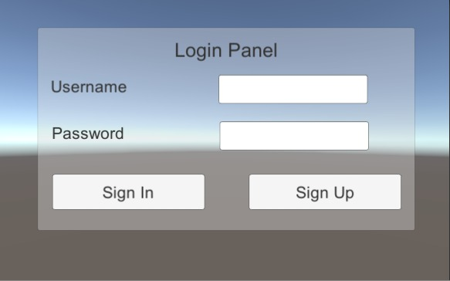

Figure 5.1 Login Screen

The login screen used the offline database, and he/she can change the mobile all the progress will undo

* + 1. **Create Account**

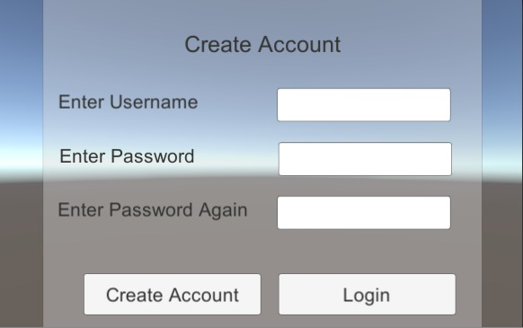

Figure 5.2 Create Account

This helps only for the account creation.

* + 1. **Operating System**

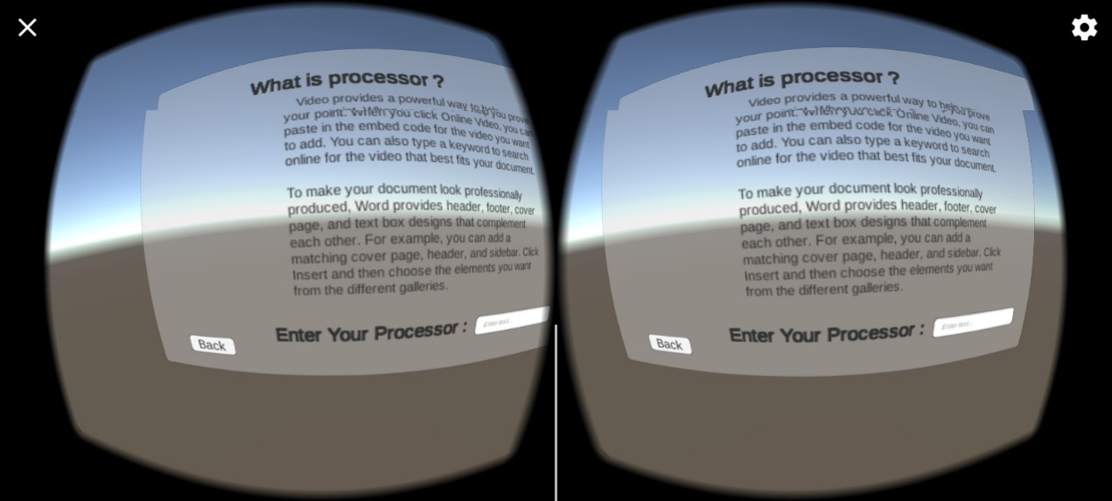

Figure 5.3 Operating System

VR Learning Part of Operating System, includes some definitions and concept of Virtualization

* + 1. **Docker**

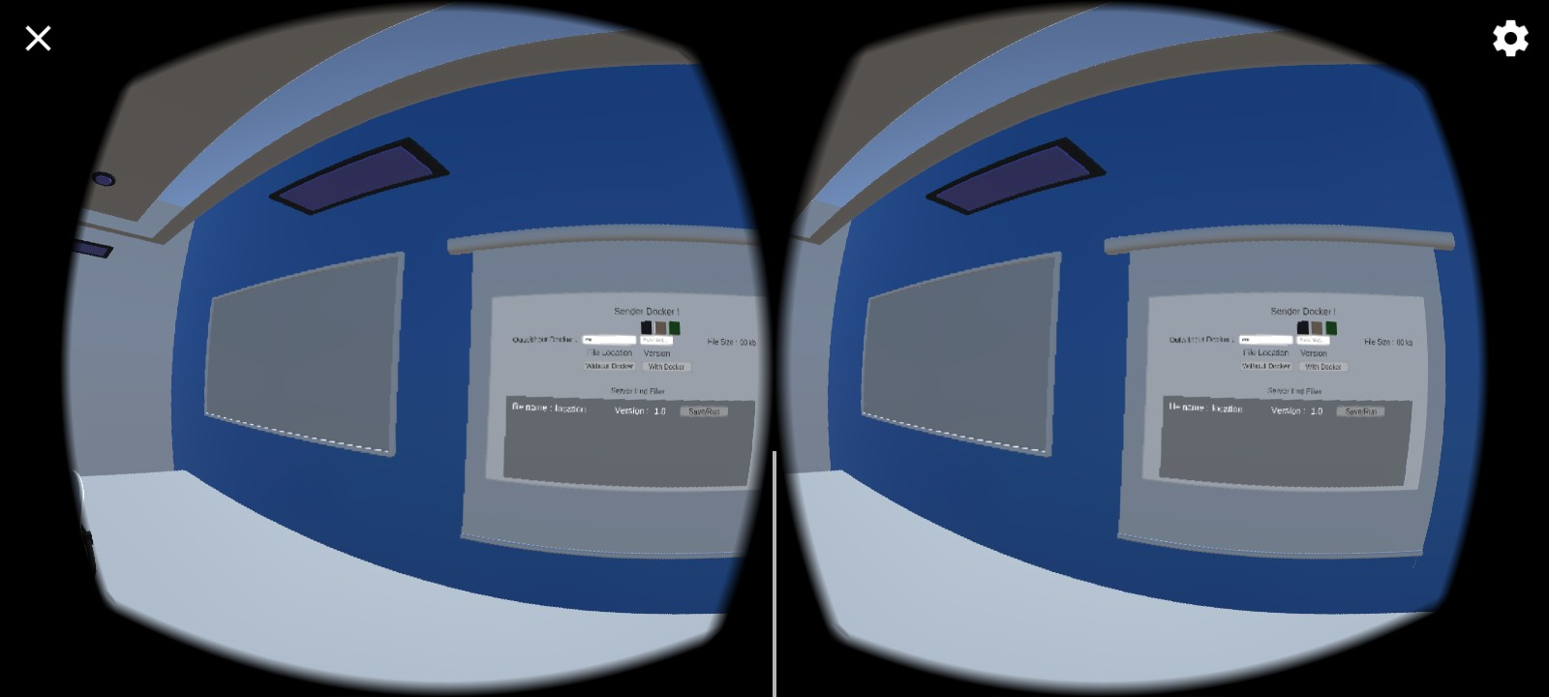

Figure 5.4 Docker

Concept of Docker Image vs non-Docker Image

* + 1. **Kubernetes**

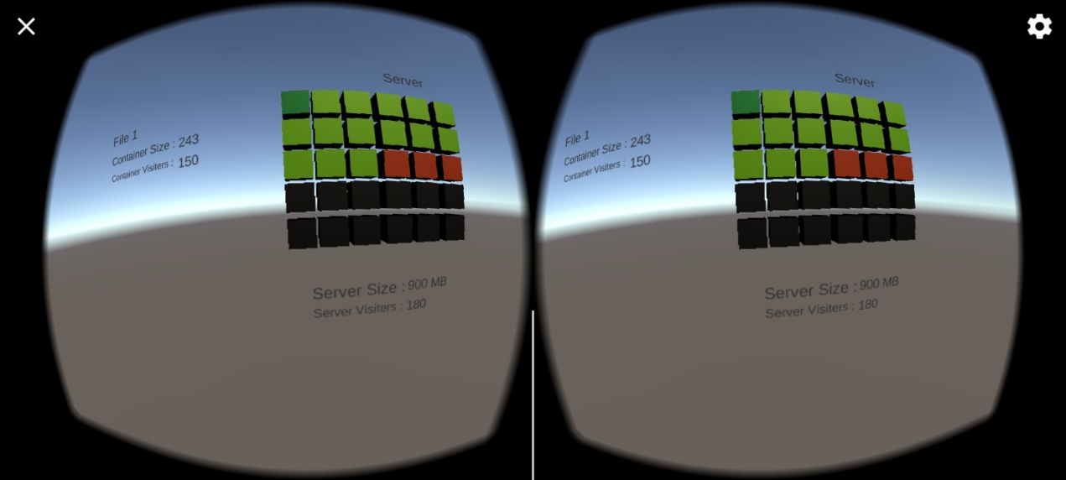

Figure 5.5 Kubernetes

Concept of Load balancing showing in this figure

**CHAPTER 6**

**Evaluation**

**6.1 Evaluation:**

Our focus was on deep testing every aspect of our project. Every functionality is tested and then iterated according to the development methodology.

**6.1.1 Unit Testing**

Each module of the project was tested, there are multiple modules like a player, Environment designing, VR Moments, and Joystick working.

The following test is performed in unit testing:

* Testing Player object choice

Table 6.1 Unit Testing

|  |
| --- |
| **Test Case #** 1 **Test Designed by:** Nabeel Ahmed  **Test Priority** (Low/Medium/High): High **Test Designed date:** 4/5/2022  **Module Name:** Testing Player object selection. **Executed by:** Kashir Hasnain  **Test Title:** Testing Player object selection. **Test Execution date:** 6/5/2022  **Description:** Test all the objects in the project that when we select the objects then they are working or not. |
| Pre-conditions: we must check whether the pointing device is connected or not. |

|  |  |  |  |  |  |
| --- | --- | --- | --- | --- | --- |
| tep | Test step | Test data | Expected system response | Pass/  Fail | notice |
| 1 | Enter an object selection page | object | The object selection page should be open | pass |  |
| 2 | Check post-condition 1 |  |  |  |  |
| 3 | Click object | Object clicked | User able to click the object | Pass | Successfully selected |
| 4 | Check post-condition 2 |  |  |  |  |
| 5 | Click object | Object not clicked | User not able to click the object | Fail | Not successfully selected |

|  |
| --- |
| Post-conditions 1:  The user has been able to click any object  Post- condition 2:  User is not able to click any object |

**6.2.2 Integration Testing**

After testing individual modules, we embedded the modules and started testing the integration phases.The following test is performed in Integration testing:

1. Player Learning
2. Player Gives the Quizzes
3. **Player Learning**

Table 6.2 Player Learning

|  |
| --- |
| Project Name: Learn cloud computing like a game  Test Case ID: 2 Test Designed by: Nabeel Ahmed  Test Priority (Low/Medium/High): High Test Designed date: 4/6/2022  Module Name: Player Learning Executed by: Kashir Hasnain  Test Title: Player Learning Test Execution date:4/8/2022  Description: Test whether the Player Learning module is working or not. |
| Pre-conditions: we must check that the learning page should be open. |

|  |  |  |  |  |  |
| --- | --- | --- | --- | --- | --- |
| step | Test step | Test data | Expected system response | Pass/  Fail | notice |
| 1 | Enter into a player learning page |  | The object selection page should be open | pass |  |
| 2 | Check post-condition 1 |  |  |  |  |
| 3 | Click operating system | Operating system clicked | Users can click to learn the operating system | Pass | Successfully selected |
| 4 | Click Docker | Docker clicked | Users able to click to learn the Docker | Pass | Successfully selected |
| 5 | Click operating system | Operating system clicked | Users can click to learn the Kubernetes | Pass | Successfully selected |
| 6 | Check post-condition 2 |  |  |  |  |
| 7 | Click operating system | The operating system not clicked | Users not able to click to learn the operating system | Fail | Not Successfully selected |
| 8 | Click Docker | Docker not clicked | Users not able to click to learn the Docker | Fail | Not Successfully selected or learn the operating system |
| 9 | Click operating system | The operating system not clicked | User not able to click to learn the Kubernetes | Fail | Not Successfully selected or learn the Docker |

|  |
| --- |
| Post-conditions 1:  The user has been able to learn the operating system, Docker, Kubernetes.  Post-condition 2:  The user is not able to learn the operating system, Docker, Kubernetes. |

1. **Player Gives the Quizzes**

Table 6. 3 Quiz

|  |
| --- |
| Project Name: Learn cloud computing like a game  Test Case ID: 3 Test Designed by: Nabeel Ahmed  Test Priority (Low/Medium/High): High Test Designed date: 4/6/2022  Module Name: Player gives the quizzes Executed by: Kashir Hasnain  Test Title: Player gives the quizzes Test Execution date:4/8/2022  Description: Test the giving the quizzes module is working or not. |

|  |
| --- |
| Pre-conditions: we have to check that the quizzes page should be open. |

|  |  |  |  |  |  |
| --- | --- | --- | --- | --- | --- |
| step | Test step | Test data | Expected system response | Pass/  Fail | Notice |
| 1 | Enter into a player Quizzes page |  | The object selection page should be open | pass |  |
| 2 | Check post-condition 1 |  |  |  |  |
| 3 | Click operating system | Operating system clicked | User able to give the quiz on the operating system | Pass | Successfully selected |
| 4 | Click Docker | Docker clicked | User able to give the quiz of the Docker | Pass | Successfully selected |
| 5 | Click operating system | Operating system clicked | User able to give the quiz of the Kubernetes | Pass | Successfully selected |
| 6 | Check post-condition 2 |  |  |  |  |
| 7 | Click operating system | The operating system not clicked | User not able to give the quiz of operating system | Fail | Not Successfully selected |
| 8 | Click Docker | Docker not clicked | User not able to give the quiz of Docker | Fail | Not Successfully selected or learn the operating system |
| 9 | Click operating system | The operating system not clicked | User not able to give the quiz of Kubernetes | Fail | Not Successfully selected or learn the Docker |

|  |
| --- |
| Post-conditions 1:  The user has been able to give the quiz on the operating system, Docker, Kubernetes.  Post-condition 2:  The user is not able to give the quiz of the operating system, Docker, Kubernetes. |

**6.3.3 Function Testing:**

After integration testing, we evaluated multiple fundamental game functionalities which are listed below

1. **Update Score**

Table 6. 4 Score Updating

|  |
| --- |
| Project Name: Learn cloud computing like a game  Test Case ID: 4 Test Designed by: Nabeel Ahmed  Test Priority (Low/Medium/High): High Test Designed date: 4/9/2022  Module Name: Update score Executed by: Kashir Hasnain  Test Title: Update score Test Execution date:4/10/2022  Description: Test the giving the quizzes score and check whether it is updating or not. |
| Pre-conditions: we have to check whether we are login or not quizzes. |

|  |  |  |  |  |  |
| --- | --- | --- | --- | --- | --- |
| step | Test step | Test data | Expected system response | Pass/  Fail | notice |
| 1 | Enter a player Quizzes page |  | The object selection page should be open | pass |  |
| 2 | Check post-condition 1 |  |  |  |  |
| 3 | Click operating system | Operating system clicked | Only its pass when all the parts of Quiz are done. | Pass | Successfully updated |
| 4 | Click Docker | Docker clicked | User able to give the quiz of the Docker | Pass | Successfully updated |
| 5 | Click operating system | Operating system clicked | Users able to give the quiz of the Kubernetes marks are updated | Pass | Successfully updated |
| 6 | Click operating system | OS quiz not opened | User did not go to other module quiz | Fail | Not Successfully updated |
| 7 | Click Docker | Docker not clicked | Quiz is not active | Fail | Not Successfully updated |
| 8 | Click operating system | The operating system not clicked | Users not able to give the quiz of Kubernetes marks are not updated | Fail | Not Successfully updated |

|  |
| --- |
| Post-conditions 1:  The user mark has been updated on the quiz of the operating system, Docker, Kubernetes. |

1. **Sound Testing**

Table 6. 5 Sound Testing

|  |
| --- |
| Project Name: Learn cloud computing like a game  Test Case ID: 5 Test Designed by: Nabeel Ahmed  Test Priority (Low/Medium/High): High Test Designed date: 4/11/2022  Module Name: Sound testing Executed by: Kashir Hasnain  Test Title: Sound testing Test Execution date:4/14/2022  Description: it tests the sound and check that its sound is been good and or during the explanation of the lecture. |

|  |
| --- |
| Pre-conditions: we have to check first whether the sound is on or not. |

|  |  |  |  |  |  |
| --- | --- | --- | --- | --- | --- |
| Step | Test step | Test data | Expected system response | Pass/  Fail | notice |
| 1 | Enter into a player lecture |  | The lecture page opened | pass |  |
| 2 | Check post-condition 1 |  |  |  |  |
| 3 | Click operating system | Operating system clicked | User able to lessen the lecture of operating system and sound tested | Pass | Successfully updated |
| 4 | Click Docker | Docker clicked | User able to lessen the lecture of Docker and sound evaluated | Pass | Successfully updated |
| 5 | Click operating system | Operating system clicked | User able to lessen the lecture of Kubernetes and sound tested | Pass | Successfully updated |

|  |
| --- |
| Post-conditions 1:  The user mark has been updated on the quiz of the operating system, Docker, Kubernetes. |

**CHAPTER 7**

**Conclusion and Future Work**

**7.1 Conclusions**

The purpose of our app was to give awareness to the people of Pakistan about virtual reality. We have tried our best to explain all the important steps and information in detail about our project in the above chapters.

After the complete implementation of the app in virtual reality using a VR box and joystick, we have concluded that it has competitive results. First of all, we designed the models in the blender. After that, we made created some animations in the learning phase for the new users and embedded them into Unity Hub Software.

After completion of the coding phase on the models and animations, we come up to the testing phase and executed all the phases in a flow.

**Import into IOS:**

We created this app just for Android devices. In future, this app can also be implemented in IOS devices because many people are using IOS devices in today’s era.

**Extension in Cloud Computing:**

As we have created this virtual learning game this is only for beginners. Cloud computer is the vast field so in future we add more modules like CI/CD etc.

**CHPATER 8**

**REFRENCES**

**Appendix A**

# References

[1] (n.d.). Retrieved from Learn Cloud Computing: https://www.ibm.com/cloud/learn/cloud-computing

[2] (2018). Retrieved from Kubernetes: https://kubernetes.io/docs/concepts/

[3] (2019). Retrieved from Youtube: https://www.youtube.com/watch?v=Jmt148A6jbM

[4] D, & Ahmed, D. (n.d.). Retrieved from Udemy: https://www.udemy.com/course/cloud-computing-and-virtualization-an-introduction/

*[5] Docker Images*. (n.d.). Retrieved from https://www.tutorialspoint.com/docker/docker_images.htm

[6] Hung, M.-H. (2021, Octuber). Retrieved from Research Gate: https://www.researchgate.net/publication/355492181_Docker_and_Kubernetes

[7] Shen, Z. (2014, Jan). Retrieved from ResearchGate: https://www.researchgate.net/publication/276498143_Technical_Possibilities_of_Cloud-Based_Virtual_Reality_Implementing_Software_as_a_Service_for_Online_Collaboration_in_Urban_Planning

*[8] VR Connection*. (n.d.). Retrieved from https://www.vrbound.com/guides/how-to-setup-and-use-virtual-reality-with-android-phones